Mannion, Liam [Student-PECS]
Assignment 3
Designing for user experience

Contents
Wireframe Annotations 3
Documentation 3
What The Project Does 3
The Value it Provides its Users 3
The Development Process 3
Instructions for Setting Up and Running the Project 4
Manual Testing Procedures 4
Automated Testing Documentation 4
Appendixes 6
Appendix 1 6
Appendix 2 7
Appendix 3 8
Appendix 4 9
Appendix 5 10
Appendix 6 10
Appendix 7 11
Appendix 8 11
Appendix 9 12
Appendix 10 13
Appendix 11 14
Appendix 12 14
Appendix 13 15
Appendix 14 15
Appendix 15 16
Appendix 16 16
Appendix 17 17
Appendix 18 17
Appendix 19 18
Appendix 20 20
Appendix 21 20
Appendix 22 21
Appendix 23 22
Appendix 24 22
Appendix 25 23
Appendix 26 24
Appendix 27 25
Appendix 28 25
Appendix 29 26
Appendix 30 26

Wireframe Annotations
There was not much feedback on the wireframes, but some changes have been made to improve the user experience. Please find the wireframes in Appendices 1-4. Firstly, the logo at the top left which is also a link to the home page has been removed and a clear button in the Nav bar saying home has been used instead. To not overwhelm the user with too many buttons in the nav bar, the about us has been moved to the home page directly underneath the nav bar. This provides all the important links in the nav bar for a user who is skimming the page directly for the prices and bookings or products but also putting the” about us” section at the top so that a more casual user will automatically see it, read it and connect to the brand better.
The next improvement made is to remove the “our services” page and have the services listed on the homepage to prevent the user from becoming frustrated at having to navigate multiple pages just to get basic information. Once they have decided on the service they require, they can now go to the prices and bookings page which has all the prices and a simpler booking form.

Documentation

What The Project Does
This project is a website for a fictious barber shop in Cambridge called Il Barbiere. Il Barbiere’s backstory is it was started by a former student who couldn’t afford a haircut when he first moved to Cambridge, because of this, the SEO (Search Engine Optimisation) not only uses key words regarding men’s haircuts but also uses student discount. The project aims to direct web traffic to the website when people search these key words online and ultimately increase the barber shops clientele, generating a higher profit.

The Value it Provides its Users
Il Barbiere already specialises in quality men’s haircuts and having a website will greatly benefit the business not only by reaching a wider audience but encouraging online booking will free up staff to complete other activities. For customers, being able to book online will save them time needlessly waiting in barbershops, essential for those with busy lifestyles. It is also a welcome addition to introverts, as it means they can book an appointment comfortably without speaking to someone. The website provides extra value to students as with student ID they can get a discount.

The Development Process
The revised wireframes can be found in appendices 1-4 and the finished website in appendices 5 – 9. Appendix 5 – 8 shows a zoomed-out image of the home page, our products page, prices and bookings page and the FAQ page respectively. Appendix 9 shows how the home page would look at normal size. Appendix 10 shows how the home page will look on a smaller screen’s device, note how the content wraps down to a smaller scale. This is due to the meta viewport tag in the HTML, as seen in appendix 11 alongside responsive CSS (Cascading Style Sheets) as seen in Appendix 12.

Instructions for Setting Up and Running the Project
- Ensure you have a code editor program installed on your device such as visual studio code or dream weaver
- Ensure you have a web browser software viewing program installed on your device such as live viewer
- Download the folder using the link from GitHub
- Open the folder in your preferred code editor program.
- Run the index page in your web browser software viewing program

Manual Testing Procedures
The first group of tests completed was to ensure all the links worked, one by one each link on all pages were tested and the test was successful. The next group of tests performed was to make sure the enquiry form validated input. The first test (appendix 13) missed out the @ sign in the email address. The test was successful, and an error message appeared stating no @ sign (appendix 14). The second test (appendix 15) was to put an email address with an @ sign but no TLD (Top Level Domain). This test successfully opened a new page with an error message (appendix 16). The third test was to ensure if correct information was entered the form would validate it, so a realistic email address was entered and the form successfully accepted it, see appendix 17 and 18. The final group of tests were to ensure the page content wrapped successfully for smaller screens, generally this was successful as seen in appendix 10, but the enquiry box on the prices and bookings page did not wrap successfully (appendix 19). However, this does not have a negative effect on the user as the whole page remains fully readable, this issue is caused by having a fixed width on the enquiry box but without the fixed width the enquiry box does not look professional on larger screens (appendix 20). Therefore, this bug has been kept in the website but it should not affect the user experience in anyway.

Automated Testing Documentation
For the automated testing process, the lighthouse tool in google chrome development was used, the first set of tests were on the desktop version. Appendix 21 shows the metrics for the home page, accessibility did not score green, but the other metrics did. As accessibility was slightly under a green score it was not changed.
Appendix 22 shows the metrics for the desktop version of the “our product” page, again it scored highly overall on all metrics and was slightly under on accessibility, so it remained unchanged.
Appendix 23 shows the metrics for the desktop version of the prices and bookings page, again it scored highly overall on all metrics and was slightly under on accessibility, so it remained unchanged.
Appendix 24 shows the metrics for the desktop version of the FAQ’s page, again it scored highly overall on all metrics and was slightly under on accessibility, so it remained unchanged.
Testing the mobile version of the website was not as successful, the home page (appendix 25) needed improvements in both performance and accessibility. To improve this score the pictures were changed from png to WebP files, these are smaller files which will decrease load times and provide a better image quality. The HTML was also updated to properly size the photos in the image gallery as well as resizing the original images in “Photos”, these steps will also improve the load time as the images are now in a smaller file. The colour scheme of the website was also changed to a blue background with white writing in most parts to improve visibility, the contact links were changed colour too using an anchor tag in the CSS.
These modifications greatly improved the score (Appendix 26), and the other pages were tested in the same way. Appendix 27 shows our product page, appendix 28 the prices and bookings page and appendix 29 the FAQ’S page. After these modifications I retested the homepage on the desktop version to ensure none of these changes had negatively affected the metrics (appendix 30) but these changes also improved performance and accessibility on the mobile version.

Appendixes

Appendix 1
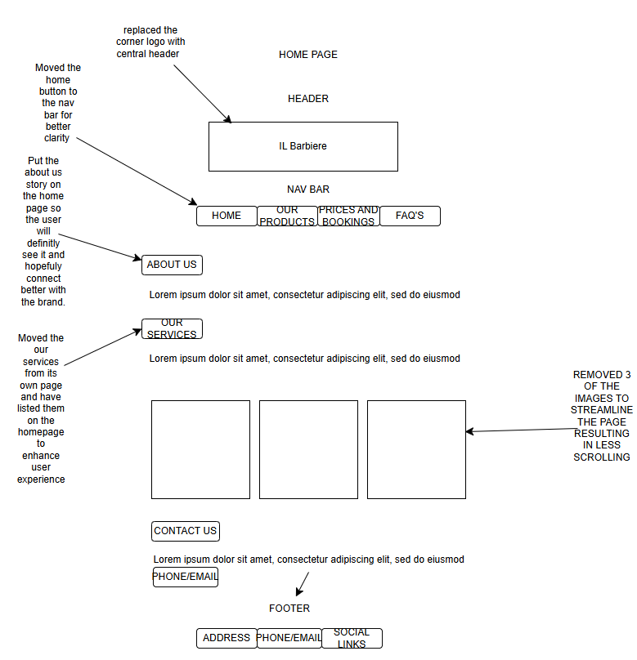

Appendix 2
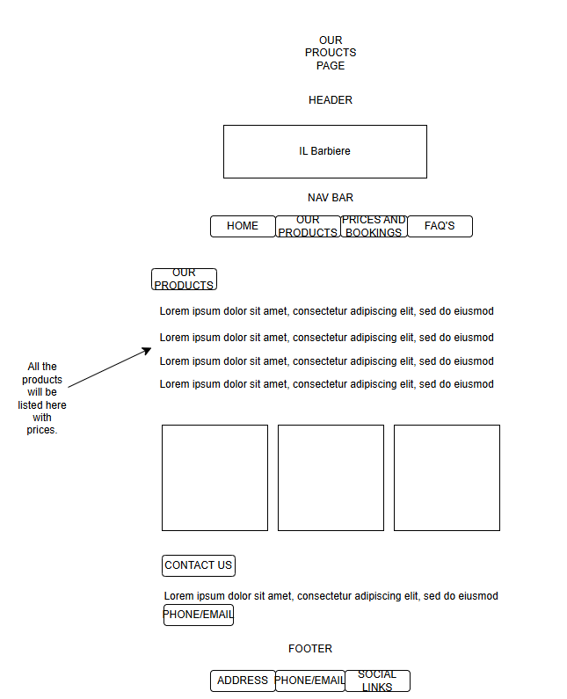

Appendix 3
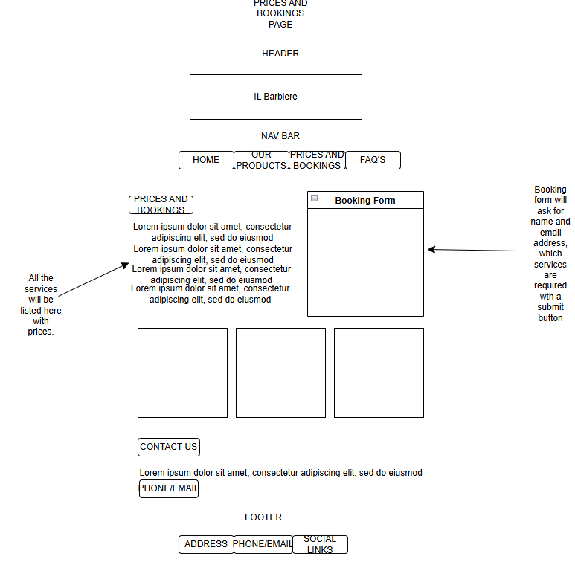

Appendix 4
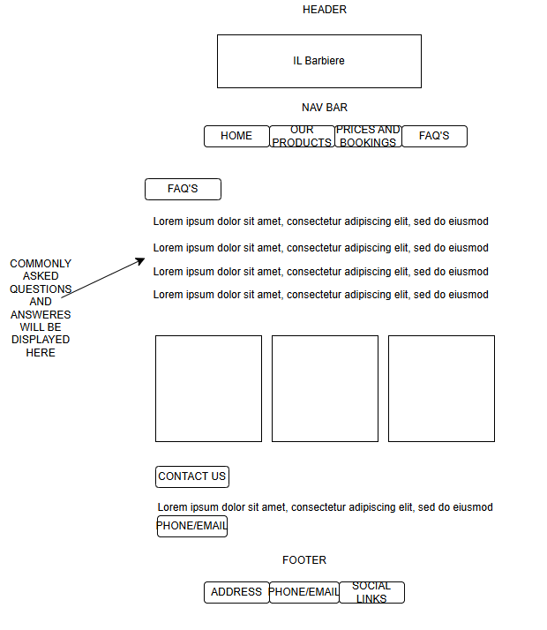

Appendix 5
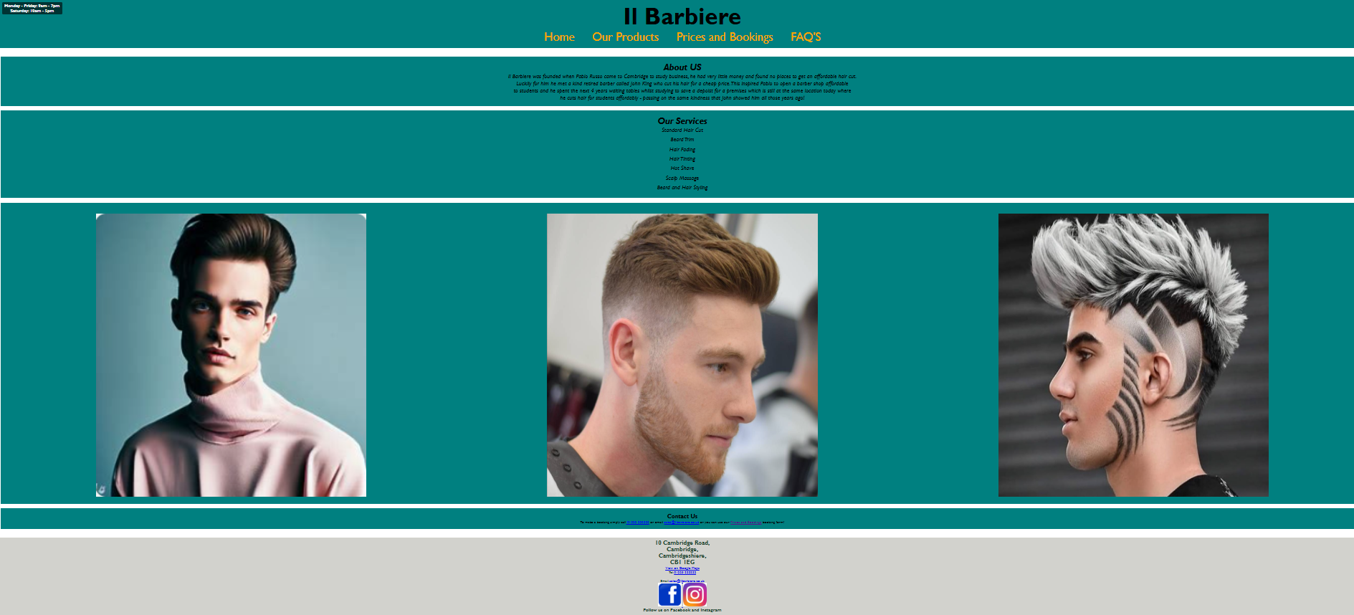

Appendix 6
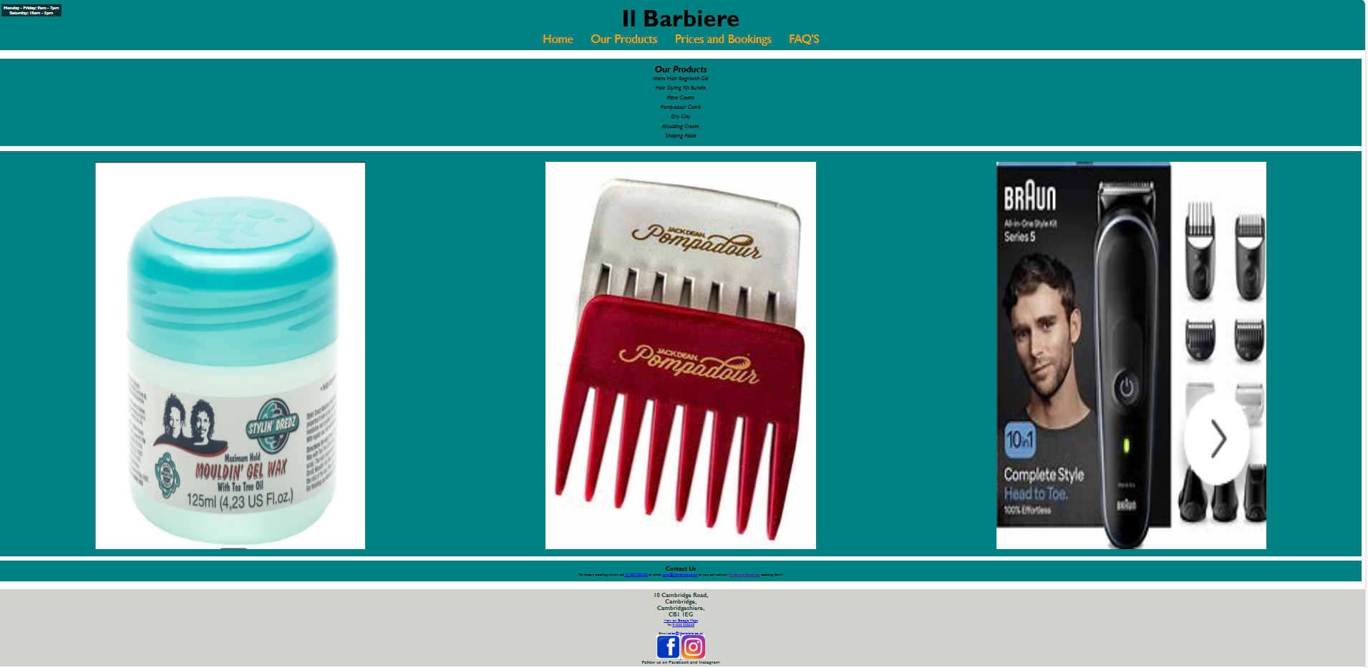

Appendix 7
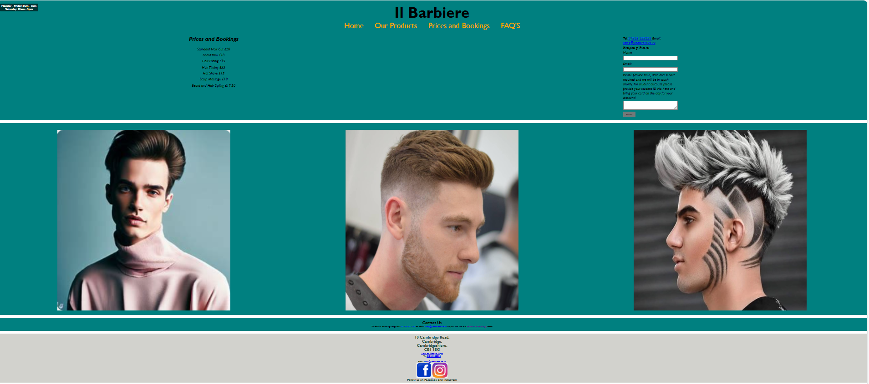

Appendix 8
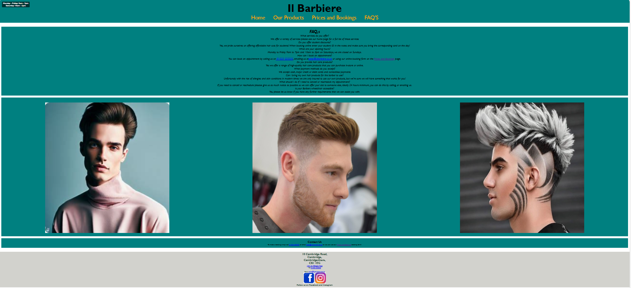

Appendix 9
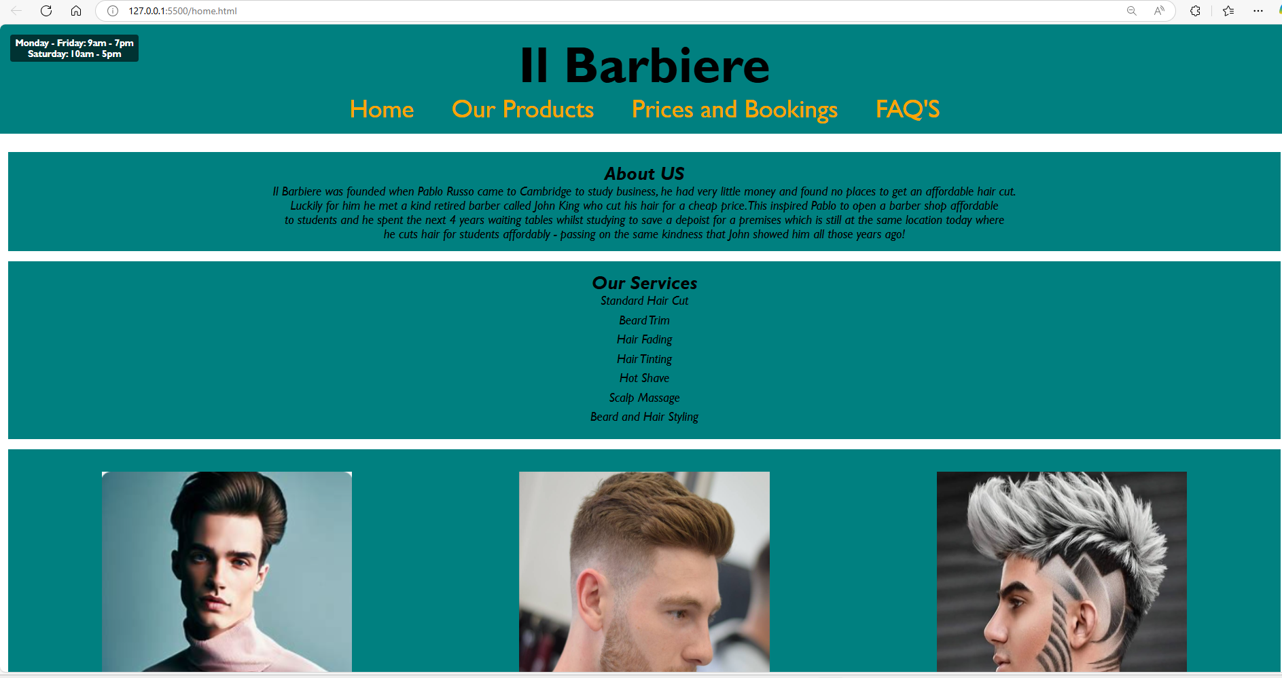

Appendix 10
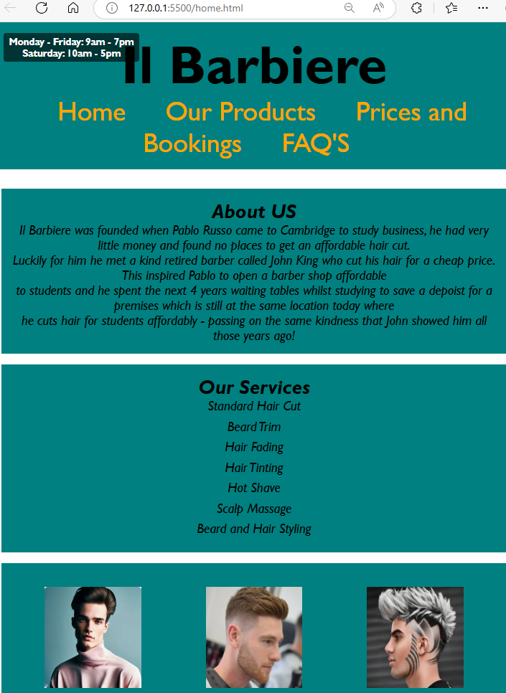

Appendix 11

Appendix 12
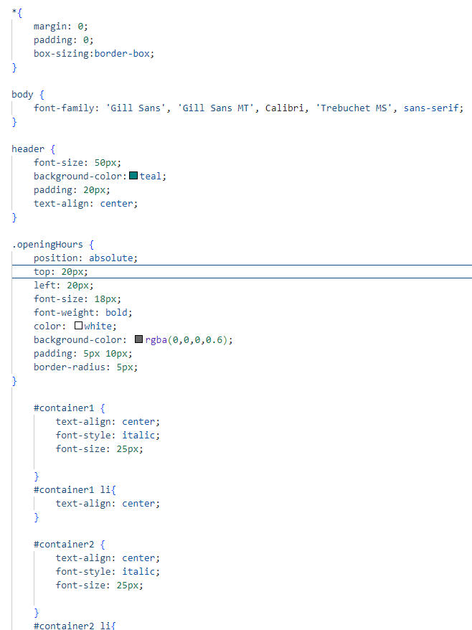

Appendix 13
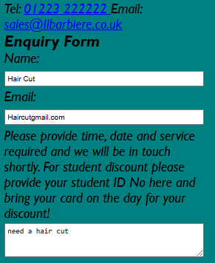

Appendix 14
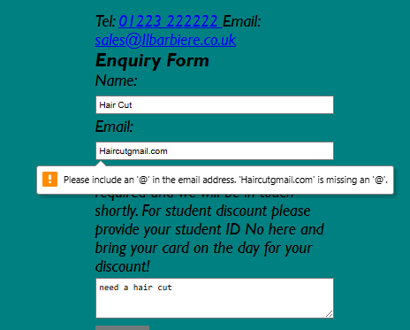

Appendix 15
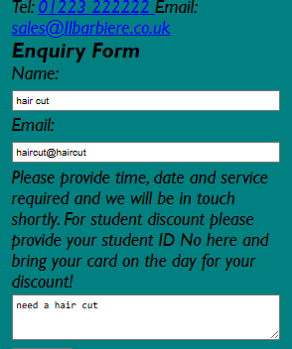

Appendix 16
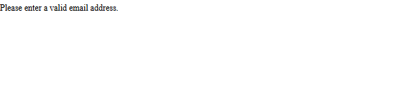

Appendix 17
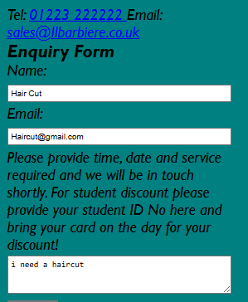

Appendix 18
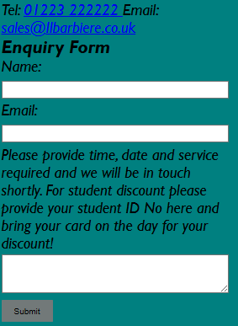

Appendix 19
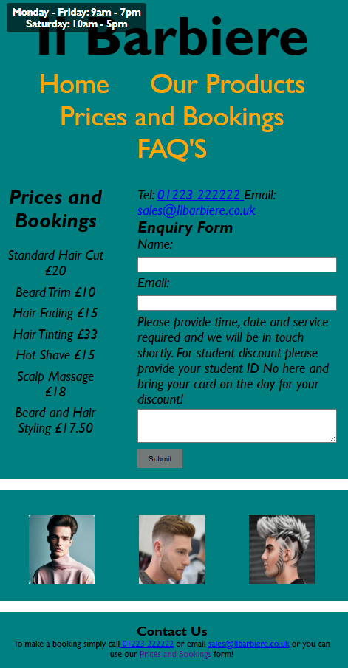

Appendix 20
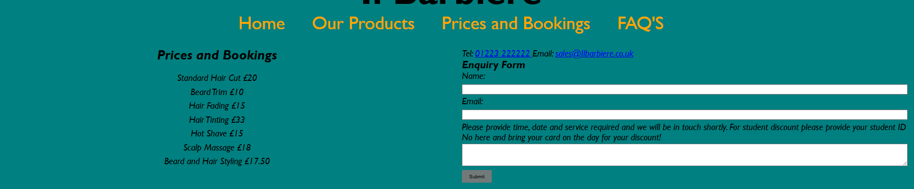

Appendix 21
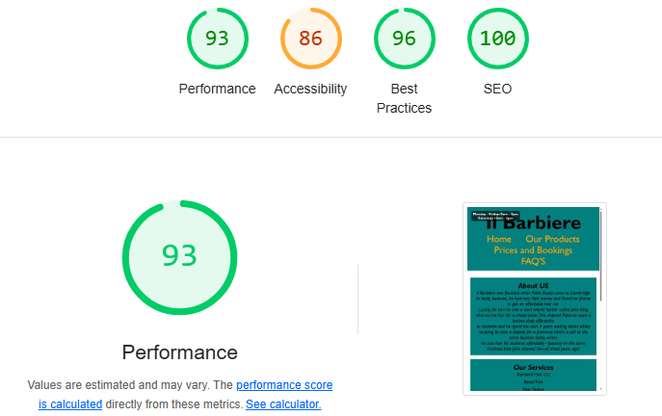

Appendix 22
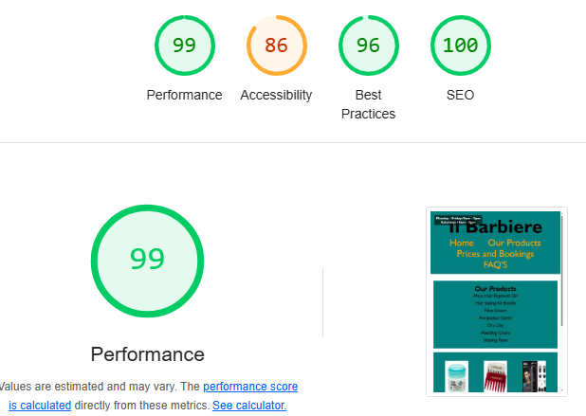

Appendix 23
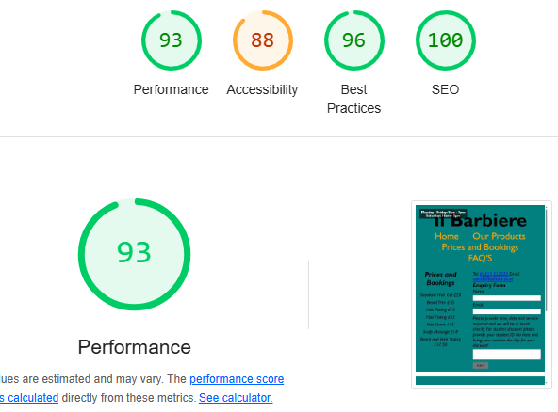

Appendix 24
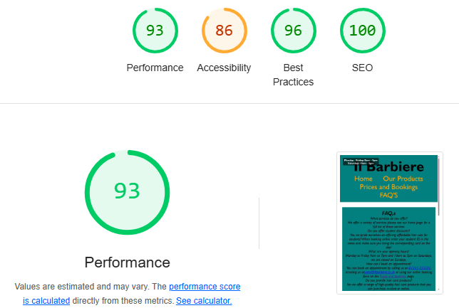

Appendix 25
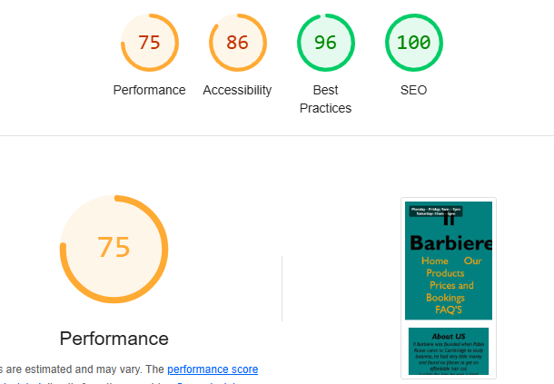

Appendix 26
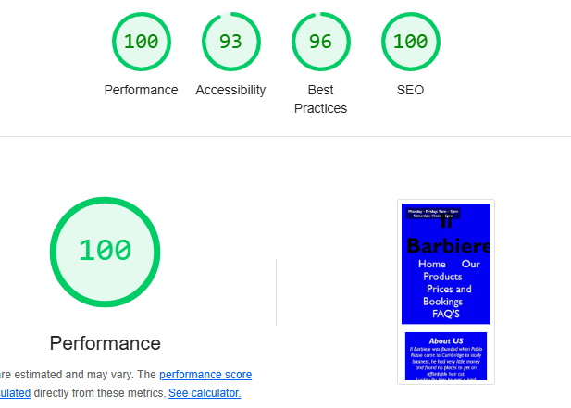

Appendix 27
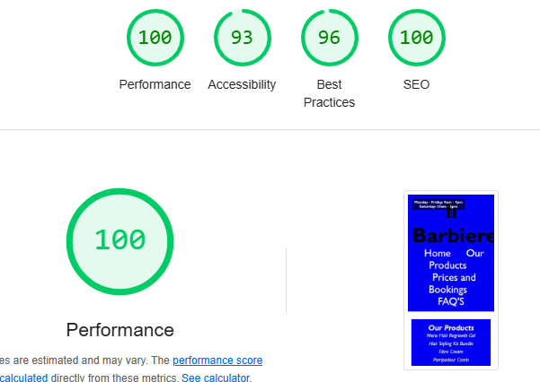

Appendix 28
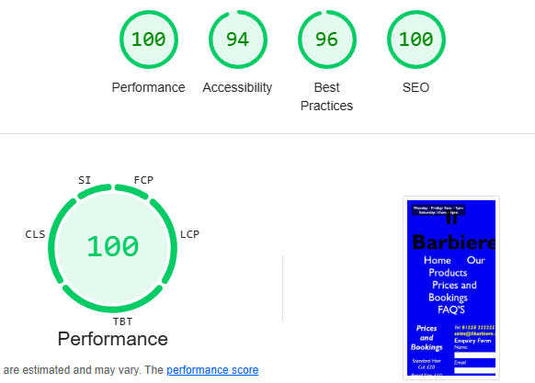

Appendix 29
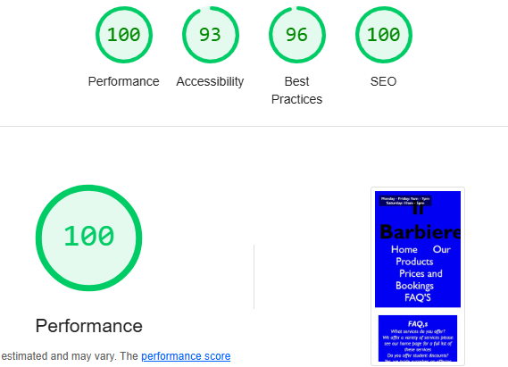

Appendix 30
